**2024 SERA Annual Business Meeting Reports**

**Report from the Chair: Tricia Miller**

Thank you to Kaitlyn Hof-Mahoney (left position at Matheson History Museum) for her service and Miranda Helton (Patriots Point Naval & Maritime Museum in South Carolina) for stepping up to fill her spot.

Thank you to Jennifer Spence and the Local Arrangements Committee for their invaluable assistance with organizing the Registrars’ Respite and BTS tour.

Respite: changes to registration for it, separated it from SEMC registration because of confusion, trying wrist band system this year

Tuesday, October 22, 2024, 8:30 pm – 10:30 pm

Location is Bengal Tap Room, 421 N. 3rd Street, 5 minute walk from hotel

Thank you to sponsors Willis Towers Watson Northeast, Inc. and Transport Consultants International.

BTS Tour

Wednesday, October 23, 2024, 2 – 4 pm

Louisiana Art & Science Museum, 100 South River Road, 5 minute walk from hotel

Thank you to Tracey Barhorst for coordinating the tour for us.

ARCS

Sebastián Encina reached out to me in January 2024 about ARCS partnering with regional organizations. I expressed interest in participating, but have not heard anything from him.

Collections Continuity Planning template

Presenting at ARCS in November. Hope to have finalized template available in first half of 2025. Thank you to Aimee Brooks, Christa McCay, Erica Hague, and Stacey Bradley for their work drafting and presenting at conferences.

**Report from the Vice Chair: Jennifer Spence**

As Vice Chair of the SERA board, I am delighted to organize this year’s SEMC SERA Respite and Behind-the-Scenes tour. The respite will take place at the Bengal Tap Room, just a 5-minute walk from the conference hotel at 421 N 3rd Street. We’ve reserved the Tap Room’s patio exclusively for our event. Registered SERA members will receive wristbands for complimentary drinks, and a delicious assortment of appetizers will be available. I would like to extend sincere thanks to our SERA respite sponsors, TCI and Willis Towers Watson, whose support has made this event possible.

For the SERA Behind-the-Scenes tour tomorrow, we’ll be visiting the Louisiana Art & Science Museum, conveniently just a 5-minute walk from the hotel. It’s sure to be a great experience, and we are deeply grateful to the museum for hosting us.

While I won’t be able to attend the SEMC annual meeting this year, I’ll miss the chance to reconnect with all of you. I look forward to hearing all the highlights, especially about the SERA events.

**Report from the Treasurer/Membership Chair – Miranda Helton**

2024 has been a great year for SERA! We have seen a 6.9% increase in membership and welcomed 35 brand new members. We have also seen sturdy income from sales of *Basic Condition Reporting* and our sponsorships.

We were able to give two travel scholarships for SEMC this year:

* Emerging Professional – Jennifer Glaze, Atlanta History Center
* Seasoned Professional – Erica Hague, Atlanta History Center

Thank you to Willis Towers Watson and TCI for their continued support of SERA with donations of $1000 each!

**Memberships (As of October 11, 2024)**

* 109 total 2024 SERA Members in Good Standing (+6.9% from 102 members before SEMC 2023)
  + 3 Associate Members
  + 63 Individual Members
  + 40 Institutional Members from 8 Institutions
  + 3 Student Members
* 35 New Members in 2024
* 39 2023 Members have not renewed

**Membership Reminders**

* Membership dues allow eligibility for scholarships, attendance at SERA-sponsored SEMC events, discounts on supplies and shipping with Gaylord, and access to SERA News and the members’ only section on the SERA website.
* Dues provide SERA with funds to pay for travel scholarships.
* A SERA membership is separate from SEMC membership.
* SERA memberships operate on a calendar year. All memberships expire on Dec. 31st.
* If you have questions about the status of your membership, do not hesitate to contact the Treasurer / Membership Chair at: [seregistrars@gmail.com](mailto:seregistrars@gmail.com)

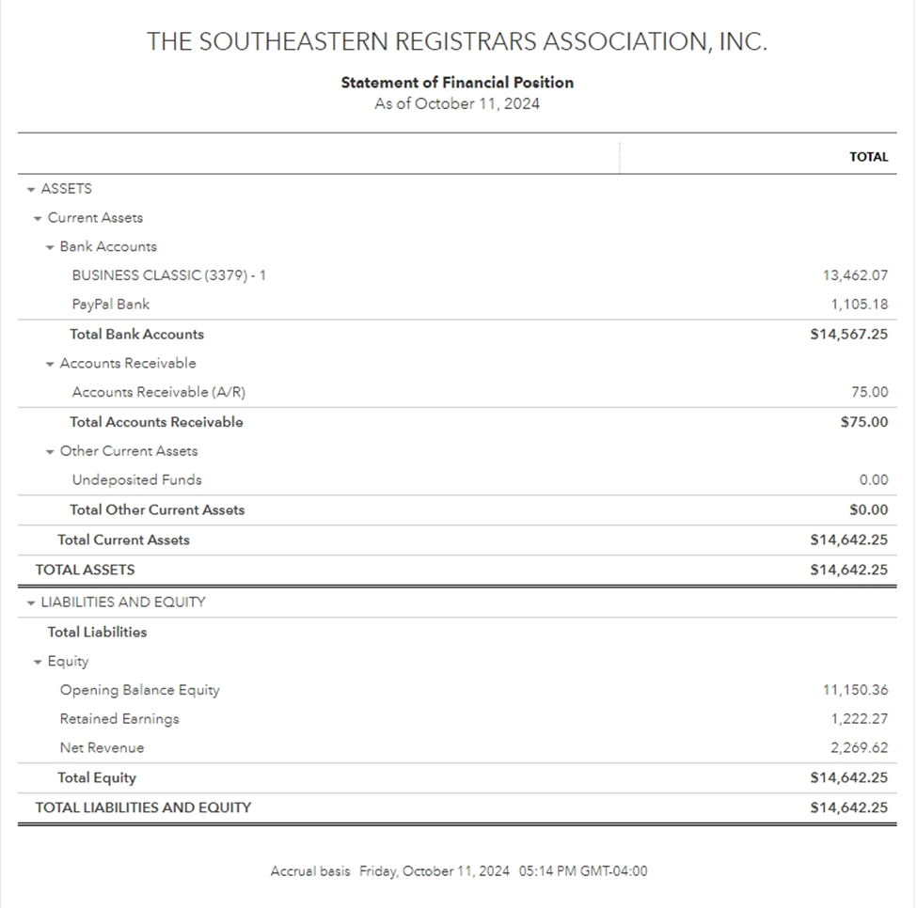

**Report from Development Chair: Ainsley Powell**

-          Emailed five different companies requesting sponsorships which would support the annual SERA Respite at the SEMC Conference.

-          A big THANK YOU goes out to the two companies who continued their support this year:

o   Transport Consultants International, Inc. - $1,000

o   Willis Towers Watson Northeast, Inc. - $1,000

**Report from the Secretary – Prepared by Alyssa Magnone - 2024**

SERA’s Annual Business Report will be filed in the next 30 days.

The election results were announced at the annual business meeting and luncheon during the SEMC annual meeting. We had 42 voting members, who voted unanimously.

Returning for a second term:

Secretary: Alyssa Magnone

Development Chair: Ainsley Powell

Communications Chair: Sabra Gossett

We’d like to welcome:

Miranda Helton, who has graciously taken over the remainder of Kaitlyn Hof-Mahoney’s term of Membership/Treasurer Chair.

We will miss you, Kaitlyn!

Thank you very much to our Election SERA Nominations Committee:

Christy Sinksen, Chair

Associate Registrar, Georgia Museum of Art, University of Georgia, Athens

Kimberly Terbush

Collections and Registration Consultant, Terbush Art, Greensboro, North Carolina

Cheryl Waldrep

Museum Curator, Natchez National Historic Park, Mississippi

We appreciate all you have done to make this election happen!

Thanks to all those who were able to attend SEMC and to those who contributed to the sessions. Another year has passed, and we look forward to seeing you in 2025 in Montgomery!!

**Report from the Communications Chair**

Hello fellow basement dwellers!

Thank you for allowing me to be your Communications Chair for the last two years, and for having the confidence in me to keep me in the position for the next two!

I am not at SEMC this year, as I recently accepted a new position as Curator of the Space Force Museum in Cape Canaveral, Florida. Don’t worry, you’ll definitely see me at SEMC 2025 and maybe at a FAM (Florida Association of Museums) event in the future!

One of my main jobs is producing the quarterly newsletter. The deadline for the Fall 2024 newsletter is November 20, so make sure to get your news to your state representative. If you don’t know who your state representative is, check the SERA website (seregistrars.org), under the “about” tab. We want to hear all the good things going on at your museum and all the fun you had at SEMC!

I also maintain SERA’s Facebook and LinkedIn accounts. We have 720 followers on Facebook! That’s amazing, considering we only have 125 paid memberships. We have 82 followers on LinkedIn. This leads me to urge you to not only follow us on Facebook and LinkedIn, but make sure to renew your memberships. There is so much good stuff in the members-only newsletters that never make it to our social media.

Finally, every week, as best as I can, I add jobs to our job board. I welcome any job listing relevant to registrarial/curatorial work. Since I came on in late 2022, we’ve had the following jobs posted:

2022 – 1337 Jobs Listed

2023 – 719 Jobs Listed

**2024 – 497 Jobs Listed (as of 9/17/2024), projected to be over 650 by the end of the year**

3257 jobs, dating all the way back to September 2020, are available for viewing at any time on our job board on seregistrars.org.

Here’s to a great SEMC and another fun year of being museum professionals! See you in 2025!

Sabra Gossett,  
Communications Chair, SERA

**Report from the Scholarship Committee – Elizabeth Le, Chair**

Committee members:

* Elizabeth Le, Collections Manager and Registrar, Hunter Museum of American Art, Chattanooga, TN
* Kaitlyn Hof-Mahoney, formerly the Executive Director, Matheson History Museum, Gainesville, FL
* Alyssa Magnone, Associate Preservation Specialist, Northeast Document Conservation Center
* Cathy DiSilvey, Registrar/Curator for the Virginia Military Institute Museum System, Lexington, VA

The Board met this Spring to discuss the scholarships offered by SERA which includes AAM, SEMC and ARCS.  A decision was made to eliminate the AAM scholarship and put more funds into SEMC scholarships by increasing the travel scholarship from $750 to $900 for the Emerging and Seasoned awards.

SERA will continue to support the ARCS scholarship. The 2024 conference will be virtual, so we are offering three $150 awards. The deadline is Nov. 15 if you are interested in applying. Requirements include a Completed Application Form, Cover Letter, Resume, 1 Letter of Recommendation. Next year the ARCS conference will be in St. Louis and SERA will offer one award.

The SEMC award winners for this year are **Erica Hague**, Collections Manager at the Atlanta History Center, for the Seasoned Professional award, and **Jen Glaze**, Associate Registrar at the Atlanta History Center, for the Emerging Professional award.

Finally, thank you to my fellow Scholarship Committee members for their time throughout the year in reviewing scholarship applications.

**Southeastern Registrars Association (SERA)**

**Annual Business Meeting & Luncheon**

**Tuesday, October 22, 2024**

**2024 Report from the SERA Nominations Committee**

**Christy Sinksen (Chair)**

Associate Registrar, Georgia Museum of Art, University of Georgia, Athens

**Kimberly Terbush**

Collections and Registration Consultant, Terbush Art, Greensboro, North Carolina

**Cheryl Waldrep**

Museum Curator, Natchez National Historical Park, Mississippi

The SERA Nominations Committee is responsible for developing a slate of nominees for SERA’s officer election that takes place each year.  Beginning on June 11 the committee publicized the call for nominations for the available offices via the SERA newsletter, emails to the SERA membership list, and posts to SERA’s Facebook page.  As of the close of nominations on September 2, the following three eligible candidates had nominated themselves and submitted bios to the committee:

Development Chair (one nominee)

**Ainsley Powell,** Curator of Collections, City of Raleigh's Historic Resources and Museum Program, North Carolina

Secretary (one nominee)

**Alyssa Magnone**, Associate Preservation Specialist, Northeast Document Conservation Center, Aiken, South Carolina

Communications Chair (one nominee)

**Sabra Gossett,** Collections Manager, Berman Museum, Anniston Museums & Gardens, Alabama

The above slate of candidates was presented to Alyssa Magnone, SERA Secretary, on September 9 to serve as the ballot for this year’s SERA election.